CMCJ Arthritis
RHH Medical Ltd summary of assessment, technique and post injection advice
December 2019

Assessment
Grind test and palpate.
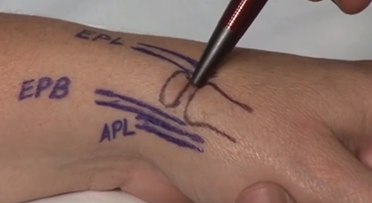

Injection
Just dorsal to EPB. https://www.youtube.com/watch?v=wQfjVk7dM1k&t=204s
2mls injection, 20-30 degrees from vertical.
Small amount subcutaneous. Then distract and rest into CMCJ. 5mm proximal entry point
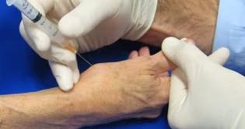

Post injection
After 5 minutes - Observe for any swelling or significant bleed. Any benefit?
Avoid loaded rotation/twisting and lifting for 48hrs
Advise exercises when immediate pain settled as per leaflet on osteoarthritis of the thumb from South Tees Hospitals.
https://southtees.nhs.uk/content/uploads/MICB4531-V1-Osteoarthritis-Thumb-Joint-9.pdf

